Background

DBHDS staff developed this document to establish a common set of sub-state regions for use across its divisions and offices. The Data Warehouse Team initiated this effort to ensure accurate and consistent data from CCS 3 and CARS in its One Source data warehouse and accurate analyses and reports. The Human Rights and Licensing Offices and the Division of Behavioral Health Services are reorganizing or establishing their regional staffing assignments and supported the need for a common set of sub-state regions. The DBHDS staff who developed this draft included Connie Cochran, Mindy Conley, Adrienne Ferriss, Paul Gilding, Stacy Gill, Daniel Herr, Judi Kuhn, Joel Rothenberg, Allen Wass, Cleo Booker, Dee Keenan, Deb Lochart, Tammy Peacock, and Beverly Rollins. This draft incorporates the following decisions.
1. Alleghany Highlands CSB will be in Primary DHDS Region 1 for all program areas. Currently, it is in Health Planning Region (HPR) I only for behavioral health services.
2. Southside CSB will be in sub-region 3.b of Primary DBHDS Region 3. Currently, it is in Partnership Planning Region (PPR) 6 because all three CSBs in this PPR receive services from Southern Virginia Mental Health Institute. Although the CSB is physically in HPR 4, it has little or no involvement in the HPR 4 regional CSB group.
3. The Primary DBHDS Regions listed on the following page will be the main regional designations for DBHDS. There are two sub-regions in Primary DBHDS Region 3 that basically retain the old PPR 6 and PPR 7. So the effect of moving to the Primary DBHDS Regions for behavioral health services will be minimal. Regional funds currently allocated to PPRs 6 and 7 will continue to be allocated to sub-regions 3.a and b. Sub-region 3.a will continue receiving state hospital acute inpatient services from Catawba Hospital, and sub-region 3.b will continue to receive those services from Southern Virginia Mental Health Institute.
4. A very small number of other regional designations may be established for limited or specialized purposes. The names of these other regions will be distinctly different from Primary DBHDS Region names to avoid any confusion. Any other regional designations in the future will be reviewed by the Data Warehouse team and approved by DBHDS senior management.
5. Another regional designation follows on page 4. Developmental Services Regions will be used for developmental services activities such as DD waiver operations and adult and child REACH programs. The main differences from the Primary DBHDS Regions are that Southside CSB will be in the Central Region and Northwestern Community Services, Rappahannock Area CSB, and Rappahannock-Rapidan CSB will be in the Northern Region, together with the five CSBs that are in Primary DBHDS Region 2. These differences are highlighted in red in the table on page 4.
6. With the adoption of the Primary DBHDS Regions and Developmental Services Regions, DBHDS will no longer use Health Planning Region, HPR, Partnership Planning Region, or PPR terminology to refer to DBHDS regions; this will avoid any confusion or misunderstanding.

Maps follow the descriptions of the Primary DBHDS and Developmental Services regions. These DBHDS regional designations have been reviewed and approved by all of the participating parties in DBHDS and shared with the affected CSBs and with the VACSB Executive Directors Forum at its meeting on May 5.
The Primary DBHDS Regions will be used generally by almost all of DBHDS, including the Behavioral Health Services; Forensic Services; Finance, Administration, and Technology; and Quality Management and Development Divisions and the Offices of Human Rights and Licensing.

Primary DBHDS Regions
DBHDS Region 1 (9 CSBs) | DBHDS Region 3 (continued)
Alleghany Highlands CSB | New River Valley Community Services
Harrisonburg-Rockingham CSB | Piedmont Community Services²
Horizon Behavioral Health | Planning District One Behavioral Health Services
Northwestern Community Services | Southside CSB²
Rappahannock Area CSB | DBHDS Region 4 (7 CSBs)
Rappahannock-Rapidan CSB | Chesterfield CSB
Region Ten CSB | Crossroads CSB
Rockbridge Area Community Services | District 19 CSB
Valley CSB | Goochland-Powhatan Community Services
DBHDS Region 2 (5 CSBs) | Hanover County CSB
Alexandria CSB | Henrico Area MH and Developmental Services
Arlington County CSB | Richmond Behavioral Health Authority
Fairfax-Falls Church CSB | DBHDS Region 5 (9 CSBs)
Loudoun County Department of Mental Health,  Substance Abuse and Developmental Services | Chesapeake Integrated Behavioral Healthcare
 | Colonial Behavioral Health
Prince William County CSB | Eastern Shore CSB
DBHDS Region 3 (10 CSBs) | Hampton-Newport News CSB
Blue Ridge Behavioral Healthcare¹ | Middle Peninsula-Northern Neck CSB
Cumberland Mountain CSB | Norfolk CSB
Danville-Pittsylvania Community Services² | Portsmouth Department of Behavioral  Healthcare Services
Dickenson County Behavioral Health Services
Highlands Community Services | Virginia Beach CSB
Mount Rogers CSB | Western Tidewater CSB
¹ Part of sub-region 3.a in Region 3 ² Part of sub-region 3.b in Region 3

There are two sub-regions in Region 3, sub-regions 3.a and 3.b, related to the catchment areas of Catawba Hospital (adult psychiatric beds) and Southern Virginia Mental Health Institute respectively, utilization of beds in those state hospitals, and the allocation and use of DAP and LIPOS funds. CSBs in these sub-regions are part of Primary DBHDS Region 3 for all other purposes.

Region 3 Sub-regions | CSBs
Sub-region 3.a | Blue Ridge Behavioral Healthcare
Sub-region 3.b | Danville-Pittsylvania Community Services
 | Piedmont Community Services
 | Southside CSB

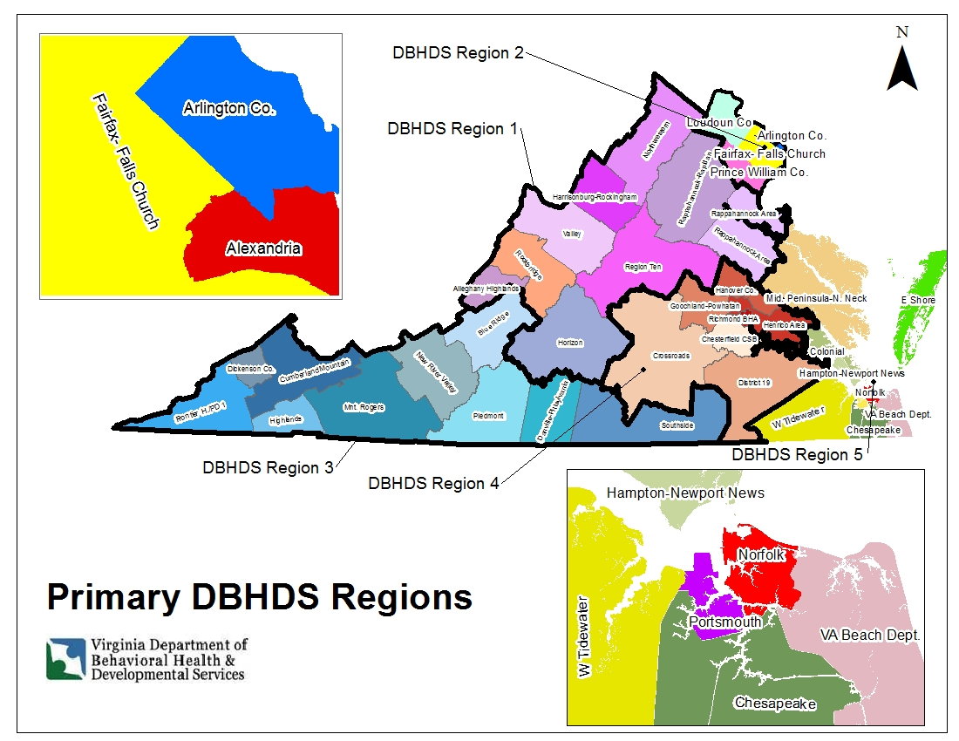

The Developmental Services Division identified the need for different regional designations because it may be not be able to match the Primary DBHDS Regions exactly. Specifically, it needs a larger northern Virginia region and the resulting larger population base for the DOJ Trust Fund, and two additional staff will be assigned to the enlarged Developmental Services (DS) Northern Region for the increased number of assessments, waiver pre-authorizations, and waitlist management needs. The DS Northern Region is created by moving Northwestern Community Services, Rappahannock Area CSB, and Rappahannock-Rapidan CSB from Primary DBHDS Region 1 into the Northern Region. Also, the DS Central Region is created by moving Southside CSB from Primary DBHDS Region 3 into the Central Region so that Southside CSB can be served by the REACH home in the Central Region. These CSBs are highlighted in red typeface in the table below. Otherwise, the regional CSB assignments in the Developmental Services Regions are identical to those in the Primary DBHDS Regions.

Developmental Services (DS) Regions
Western Region (6 CSBs) | Southwest Region (continued)
Alleghany Highlands CSB | New River Valley Community Services
Harrisonburg-Rockingham CSB | Piedmont Community Services
Horizon Behavioral Health | Planning District One Behavioral Health Services
Region Ten CSB | Central Region (8 CSBs)
Rockbridge Area Community Services | Chesterfield CSB
Valley CSB | Crossroads CSB
Northern Region (8 CSBs) | District 19 CSB
Alexandria CSB | Goochland-Powhatan Community Services
Arlington County CSB | Hanover County CSB
Fairfax-Falls Church CSB | Henrico Area MH and Developmental Services
Loudoun County Department of Mental Health,  Substance Abuse and Developmental Services | Richmond Behavioral Health Authority
 | Southside CSB²
Northwestern Community Services¹ | Eastern Region (9 CSBs)
Prince William County CSB | Chesapeake Integrated Behavioral Healthcare
Rappahannock Area CSB¹ | Colonial Behavioral Health
Rappahannock-Rapidan CSB¹ | Eastern Shore CSB
Southwestern Region (9 CSBs) | Hampton-Newport News CSB
Blue Ridge Behavioral Healthcare | Middle Peninsula-Northern Neck CSB
Cumberland Mountain CSB | Norfolk CSB
Danville-Pittsylvania Community Services | Portsmouth Department of Behavioral  Healthcare Services
Dickenson County Behavioral Health Services
Highlands Community Services | Virginia Beach CSB
Mount Rogers CSB | Western Tidewater CSB
¹ Part of a sub-region in the DS Northern Region for developmental services; these CSBs are in Primary DBHDS Region 1 for other services and purposes.
² Part of a sub-region in the DS Central Region for developmental services; this CSB is in Primary DBHDS Region 3 for other services and purposes.

